YEAR 12 CHEMISTRY – 3BCHE

PRACTICAL TEST

Volumetric Analysis – Sensorimotor (20 marks)

Recommended time: 60 minutes
Total marks

/ 40
Name: SOLUTIONS
Teacher: _____________________________________________________

ACID-BASE VOLUMETRIC ANALYSIS

Sodium carbonate (Na₂CO₃) can be used as a primary standard for acid base titrations. This is because it satisfies the following characteristics

- It has a relatively high molar mass (105.99 g mol⁻¹)
- It is not hygroscopic or deliquescent which leads it to have constant mass as it does NOT absorb moisture from the air
- Available in high degree of purity.
In domestic use, Na₂CO_{3,} it is used as a water softener in laundering. It competes with the magnesium and calcium ions in hard water and prevents them from bonding with the detergent being used. Sodium carbonate can be used to remove grease, oil and wine stains. It is sold as washing soda, soda crystals, or sal soda. Sodium carbonate is also used as a descaling agent in boilers such as those found in coffee pots and expresso machines.
Another use is that it can be used as a buffer in swimming pools and other solutions.
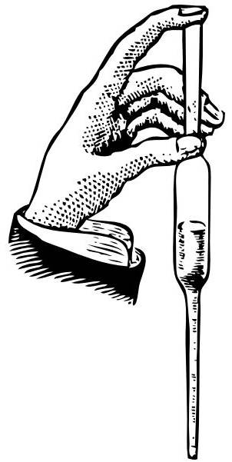
Procedure:

- Use a pipette to transfer a 20.0 mL aliquot of the sodium carbonate solution into ONE of the conical flasks given.
Put up your hand and ask your teacher to assess your 20.0 mL aliquot.

3

- Titrate the 20.0 ml aliquot of sodium carbonate (conical flask) against the hydrochloric acid solution from the burette by selecting ONE of the two indicators provided. Put up your hand and ask your teacher to assess the colour at the end point.
3

- Repeat Steps 1 – 2. You may elect to perform a third titration (optional) if required.

- Calculate the concentration of hydrochloric (HCl) solution (in molL⁻¹) from your trials. Take note of the value of the concentration of standardised Na₂CO₃ on the white board at the front of the class.

Overall acid-base equation:
2
Write a balanced IONIC chemical equation for the titration reaction between HCl and Na₂CO₃in the space provided below.
Include the states of matter.

2H⁺ + CO₃²⁻ → H₂O + CO₂

Results: Complete the table below
3

Burette Reading

Sample number | 1 | 2 | 3 (optional only)
Final Volume (V₂)

Initial Volume (V₁)

Titration Volume (mL)
(ΔV) = V₂ - V₁

2
Average titration Volume = 25.55 mL

Calculation:

Concentration of standardised Na₂CO₃ (from the WHITEBOARD) = ___0.0500047____ mol L⁻¹

Final concentration = 0.078438
= 7.84 × 10⁻² mol L⁻¹ [2 sig fig]

Marking: Final concentration between
4 marks - 7.79 × 10⁻² & 7.89 × 10⁻²
3 marks 7.74 × 10⁻² & 8.04 × 10⁻²
2 marks 7.69 × 10⁻² & 8.54 × 10⁻²
1 mark 7.64 × 10⁻² & 9.04 × 10⁻²

Final Answer

Final concentration of your hydrochloric acid solution to three (3) significant figures [HCl ]= _________________ mol L⁻¹

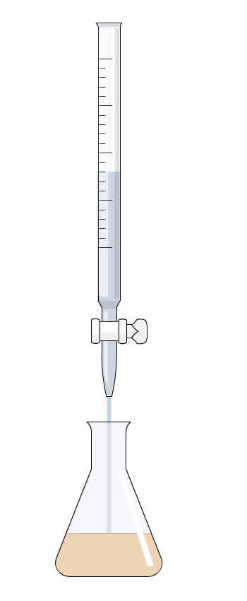
4
Marks for working out
_{Accuracy} | ₀ | ₁ | ₂ | ₃

Volumetric Analysis – Written Section (20 marks)

Name: _____________________________________________________

Teacher: _____________________________________________________

In each of the following, write the correct name, formula, number or descriptive term that best match the description.

1 | A name given to a solution of exactly known concentration that can be obtained highly pure with a known formula and high molecular mass. | Primary standard
2 | ONE (1) example of a substance that satisfies the conditions listed in Question 1. | Na₂CO₃
3 | A name given to glass equipment used to accurately deliver a fixed volume of solution. | Pipette
4 | Name of glass equipment that must not be pre-rinsed with the solution to be added to it. | Conical flask
5 | The level of accuracy to which final and initial volumes should be read from the burette. | 2 dp
6 | A name given to the volume difference between the initial volume of and the final volume of titration. | Titre / titration volume
7 | Name of a substance that can be added to the reaction mixture in the conical flask without affecting the outcome of the titration. | Water (or indicator)
8 | Name of an indicator that should be used in the titration between a weak base and a strong acid. | Methyl Orange
9 | Name of an indicator that should be used in the titration between ethanoic acid and sodium hydroxide. | Phenolphthalein
10 | 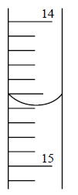  The reading (to the correct number of significant figures)  shown on the burette opposite is: | 14.59 mL
11 | 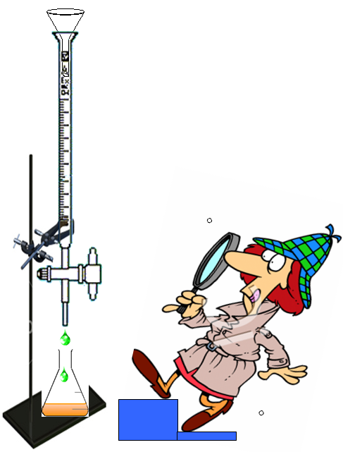  The person in the diagram opposite is attempting to take a burette reading.  State ONE (1) possible source of error from the picture.  Note: explanation is NOT required. | Parallex error,  Funnel  Dripping tap

The following questions refers to the following titration:

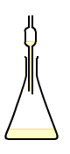

Pipette

In Questions12-14, state the correct final rinsing solution for each of the following glassware:

12 | Burette | HCl
13 | Pipette | NaOH
14 | Conical flask | Water

Questions 15-18 refer to the use of indicators in the titration above.

15 | State the change in the colour of phenolphthalein indicator as the titration proceeds. | From PINK to COLOURLESS
16 | State the pH of the reaction mixture at the equivalence point. | ~8.3
17 | State the change in indicator colour if methyl orange was used instead of phenolphthalein. | From YELLOW to RED
18 | State the pH at the end point of methyl orange indicator. | ~4.6

State the effect of the following acts on the volume of hydrochloric acid used to achieve the equivalence point in the titration above. Write your answer as more acid is needed, less acid is needed or no effect.

19 | Distilled water was used as the final rinse for the burette. | More acid is needed
20 | Sodium hydroxide was used as the final rinse for the conical flask. | More acid is needed



Lab notes:

Per student:
250 mL Na₂CO₃
250 mL of HCl
2 × 100 mL beaker (clean, dry & labelled)
1 × conical flask

Per station:
1 × burette
1 × distilled water
1 × 20 mL pipette
1 × pipette filler
1 × methyl orange
1 × larger beaker
1 × waste bucket

To make Na₂CO₃ solution:

Approx 5·30 g per litre – does not need to be an exact amount to make 0·05 mol L⁻¹
Dry in hot oven for 30 minutes and then cool in desiccator.
Make up to required volume.

Note: Teacher needs to know actual mass used and volume produced to calculate precise concentration.
Students need to know this concentration for the assessment.

HCl solution needs to be approx 0·1 M, but not exact, anywhere from 0·09 – 0·11 would be appropriate. The precise concentration needs to be determined by titration by teacher/lab staff using above Na₂CO₃.
Students need to determine this concentration for the assessment.

